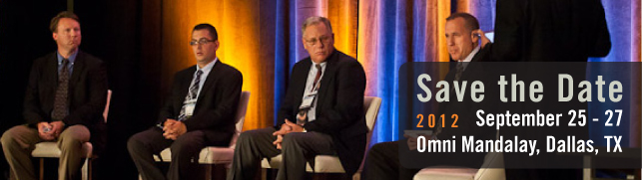
…………………………………………………………………………………………………………………………..

IDEA E-Biz Forum 2012 Speaker Submission Details
As a presenter at the IDEA E-Biz Forum 2012, you will have the chance to share your experiences, insights and fresh approaches to eBusiness with fellow professionals in the electrical wholesale and retail industry.
What we are looking for:
This year’s theme is “Reunite. Rethink. Recharge.” We are looking for sessions that will give our attendees the information they need to start working toward their eBusiness goals as soon as they return to the office. This year we will integrate more sessions on how to help IDEA customers utilize IDEA products and services more efficiently. Please be sure to identify your intended topic area with your email submission.
Are there other ways to participate?
In addition to presenting a session, you can also serve as a panelist during one of our panel discussions, receive maximum visibility as a corporate sponsor and participate as an exhibitor in the Tech Center. If you are interested in participating, please indicate your interest in your email submission.
Submission Guidelines
Please submit an abstract in English, of the topic title, objectives and summary of the presentation. Event seminar presentations should be 45 or 50 minutes long. Please note: presentations must be educational in nature and not include “sales/marketing pitches”. Speakers are encouraged to prepare and present original material. The Forum committee will carefully review all abstracts.
Key Deadlines
Completed email and abstract: March 12, 2012 *Speaker Deadline Extended for NEMA Members*
Acceptance status: March 30, 2012
Completed Presentation: August 17, 2012
If you are interested in becoming a speaker prospect for the IDEA E-Biz Forum 2012 on September 25-27 in Dallas, TX, submit the form on the next page to the Forum Committee by email, ebiz@idea-esolutions.com or by fax at 703.562.4601.

See form on next page.
IDEA E-Biz Forum 2012 Speaker Submission Form

Fill in form:
Name: | Click here to enter text.
Title: | Click here to enter text.
Company: | Click here to enter text.
Phone: | Click here to enter text.
Email: | Click here to enter text.
Interests: | Choose an item.
Topic: | Click here to enter text.
Abstract | Click here to enter text.
Short Bio | Click here to enter text.

Submit this form to the Forum Committee by email ebiz@idea-esolutions.com or fax at 703.562.4601.
We want you to speak about a topic in which you’re knowledgeable and deem significant to share. Our main goal is to increase value for attendees who have indicated high interest in the subjects below. If you share that interest and have lessons that will help others succeed, please submit a speaker form related to one of these topics. Topics to consider:
- Business strategies and organizational anecdotes for integrating social and mobile technologies into digital marketing
- Success stories/examples of how distributors are utilizing and leveraging manufacturer product information including marketing content and attributes
- Trading partner relationships that work – how manufacturers, distributors and retailers are communicating effectively to meet shared goals and objectives
- Organizational solutions for adopting and implementing the Data Management Platform (DMP) from distributor and manufacturer perspectives
- Utilizing eBusiness to accomplish green and sustainability alternatives for your business
- How to prepare your data for building information modeling (BIM)
- Strategies to generate internal buy-in of and support for data sync initiatives
- Industry trends and best practices for eCommerce, EDI and data sync
- Optimizing your eCatalog/web storefront with the product information your customers are searching for and need to make purchasing decisions
- How to prioritize your product data clean-up/integration initiatives

